A Project Report
on
LIBRARY MANAGEMENT SYSTEM

Submitted in partial fulfillment of requirements for the award of the course
of
EGB1221-DATABASE MANAGEMENT SYSTEMS
Under the guidance of

Dr. P.RAMAKRISHNAN M.E.,Ph.D.,

Assistant Professor / ECE

Submitted By
KANISHKA D (927623BEC101)
KANISHKA S (927623BEC102)

DEPARTMENT OF ELECTRONICS AND COMMUNICATION
ENGINEERING

M.KUMARASAMY COLLEGE OF ENGINEERING
(Autonomous)
KARUR – 639 113
MAY 2025

M. KUMARASAMY COLLEGE OF ENGINEERING
(Autonomous Institution affiliated to Anna University, Chennai)

KARUR – 639 113

BONAFIDE CERTIFICATE

This is to certify that this project report on “LIBRARY MANAGEMENT SYSTEM” is the bonafide work of KANISHKA D (927623BEC101) , KANISHKA S (927623BEC102) who carried out the project work during the academic year 2024 - 2025 under my supervision.

Signature | Signature
Dr.P.RAMAKRISHNAN M.E.,Ph.D., | Dr. A. KAVITHA M.E.,Ph.D.,
SUPERVISOR, | HEAD OF THE DEPARTMENT,
Department of Electronics and Communication Engineering, | Department of Electronics and Communication Engineering,
M.Kumarasamy College of Engineering, | M.Kumarasamy College of Engineering,
Thalavapalayam, Karur -639 113. | Thalavapalayam, Karur -639 113.

ii
DEPARTMENT OF ELECTRONICS AND COMMUNICATION ENGINEERING
VISION OF THE INSTITUTION
To emerge as a leader among the top institutions in the field of technical education
MISSION OF THE INSTITUTION
- Produce smart technocrats with empirical knowledge who can surmount the global challenges
- Create a diverse, fully-engaged, learner-centric campus environment to provide quality education to the students
- Maintain mutually beneficial partnerships with our alumni, industry, and Professional associations

DEPARTMENT VISION, MISSION, PEO, PO AND PSO
Vision
To empower the Electronics and Communication Engineering students with emerging technologies, professionalism, innovative research and social responsibility.
Mission
M1: Attain the academic excellence through innovative teaching learning process, research areas & laboratories and Consultancy projects.
M2: Inculcate the students in problem solving and lifelong learning ability.
M3: Provide entrepreneurial skills and leadership qualities.
M4: Render the technical knowledge and skills of faculty members.

iii

PROGRAM EDUCATIONAL OBJECTIVES (PEOs)
- PEO1: Graduates will have successful Career in software industries and R&D divisions through continuous learning
- PEO2: Graduates will provide effective solutions for real world problems in the key domain of Electronics and communication engineering engage in lifelong learning.
- PEO3: Graduates will excel in their profession by being ethically and socially responsible
PROGRAM OUTCOMES (POs)
Engineering students will be able to:
- Engineering knowledge: Apply the knowledge of mathematics, science, engineering fundamentals, and an engineering specialization to the solution of complex engineering problems.
- Problem analysis: Identify, formulate, review research literature, and analyze complex engineering problems reaching substantiated conclusions using first principles of mathematics, natural sciences, and engineering sciences.
- Design/development of solutions: Design solutions for complex engineering problems and design system components or processes that meet the specified needs with appropriate consideration for the public health and safety, and the cultural, societal, and environmental considerations.
- Conduct investigations of complex problems: Use research-based knowledge and research methods including design of experiments, analysis and interpretation of data, and synthesis of the information to provide valid conclusions.
- Modern tool usage: Create, select, and apply appropriate techniques, resources, and modern engineering and IT tools including prediction and modeling to complex engineering activities with an understanding of the limitations.
- The engineer and society: Apply reasoning informed by the contextual knowledge to assess societal, health, safety, legal and cultural issues and the consequent responsibilities relevant to the professional engineering practice.
iv

- Environment and sustainability: Understand the impact of the professional engineering solutions in societal and environmental contexts, and demonstrate the knowledge of, and need for sustainable development.
- Ethics: Apply ethical principles and commit to professional ethics and responsibilities and norms of the engineering practice.
- Individual and team work: Function effectively as an individual, and as a member or leader in diverse teams, and in multidisciplinary settings.
- Communication: Communicate effectively on complex engineering activities with the engineering community and with society at large, such as, being able to comprehend and write effective reports and design documentation, make effective presentations, give and receive clear instructions.
11.Project management and finance: Demonstrate knowledge and understanding of the engineering and management principles and apply these to one’s own work, as a member and leader in a team, to manage projects and in multidisciplinary environments.
12.Life-long learning: Recognize the need for, and have the preparation and ability to engage in independent and life-long learning in the broadest context of technological change.
PROGRAM SPECIFIC OUTCOMES (PSOs)
- PSO1: Professional Skills: Ability to apply the knowledge of computing techniques to design and develop computerized solutions for the problems.
- PSO2: Successful career: Ability to utilize the computing skills and ethical values in creating a successful career.

V
ACKNOWLEDGEMENT

We gratefully remember our beloved Founder Chairman, (Late) Thiru. M. Kumarasamy, whose vision and legacy laid the foundation for our education and inspired us to successfully complete this project.
We extend our sincere thanks to Dr. K. Ramakrishnan, Chairman, and Mr. K. R. Charun Kumar, Joint Secretary, for providing excellent infrastructure and continuous support throughout our academic journey.
We are privileged to extend our heartfelt thanks to our respected Principal, Dr. B. S. Murugan, B.Tech., M.Tech., Ph.D., for providing us with a conducive environment and constant encouragement to pursue this project work.
We sincerely thank Dr. A. Kavitha, B.E., M.E., Ph.D., Professor and Head, Department of Electronics and Communication Engineering, for her continuous support, valuable guidance, and motivation throughout the course of this project.
Our special thanks and deep sense of appreciation go to our Project Supervisor, Mr.P.Arunkumar, B.E., M.Tech., Assistant Professor, Department of Electronics and Communication Engineering, for his exceptional guidance, continuous supervision, constructive suggestions, and unwavering support, all of which have been instrumental in the successful execution of this project.
We would also like to acknowledge Mr.T.Sivakumar,B.E., M.E., (Ph.D)., Assistant Professor, our Class Advisor for their constant encouragement and coordination that contributed to the smooth progress and completion of our project work.
We gratefully thank all the faculty members of the Department of Electronics and Communication Engineering for their timely assistance, valuable insights, and constant support during various phases of the project.
Finally, we extend our profound gratitude to our parents and friends for their encouragement, moral support, and motivation, without which the successful completion of this project would not have been possible.

ABSTRACT

A Library Management System (LMS) is a robust and essential application of Database Management Systems (DBMS) that enables efficient and systematic control over library resources. In a traditional library, the manual tracking of books, members, and transactions often results in errors, redundancy, and time-consuming operations. To overcome these limitations, the LMS integrates a well-structured DBMS to store, manage, and retrieve library data quickly and reliably. The system’s core revolves around maintaining a centralized database that holds information about books, library members, issue and return transactions, due dates, fines, and staff activities. A relational DBMS such as MySQL, Oracle, or PostgreSQL is typically used to model this data in the form of interrelated tables, ensuring data integrity, security, and easy scalability. By employing concepts such as primary keys, foreign keys, normalization, and indexing, the LMS database is optimized for performance and consistency.The design of the LMS database begins with identifying entities like Books, Members, Transactions, and Librarians. Each entity is represented by a table, and relationships are established among them using foreign key constraints. For example, a ‘Books’ table might include attributes such as Book_ID, Title, Author, Publisher, and Availability_Status. Similarly, a ‘Members’ table stores Member_ID, Name, Address, Contact, and Membership_Date. The Transactions table is crucial in tracking the issuance and return of books. It contains fields like Transaction_ID, Member_ID, Book_ID, Issue_Date, Return_Date, and Fine_Amount. These structured relations enable the system to efficiently process queries, such as checking which books a member has borrowed, which books are overdue, or what fine is applicable.

ABSTRACT WITH POs AND PSOs MAPPING

ABSTRACT | COs MAPPED | POs MAPPED | PSOs MAPPED
A Library Management System (LMS) is a robust and essential application of Database Management Systems (DBMS) that enables efficient and systematic control over library resources. In a traditional library, the manual tracking of books, members, and transactions often results in errors, redundancy, and time-consuming operations. To overcome these limitations, the LMS integrates a well-structured DBMS to store, manage, and retrieve library data quickly and reliably. | CO1  CO2  CO3  CO4  CO5 | PO1  PO2  PO3  PO5  PO9  PO10 | PSO1  PSO2
Note: 1- Low, 2-Medium, 3- HighPO2

SUPERVISOR HEAD OF THE DEPARTMENT

vii

TABLE OF CONTENTS
CHAPTER  No. | TITLE | PAGE  No.
 | ABSTRACT
1 | INTRODUCTION
 | 1.1 OBJECTIVE
 | 1.2 OVERVIEW
 | 1.3 DATABASE MANAGEMENT SYSTEMS’ CONCEPTS
2 | PROJECT METHODOLOGY
 | 2.1 PROPOSED WORK
 | 2.2 ARCHITECTURE
 | 2.3 E-R DIAGRAM
3 | MODULE DESCRIPTION
 | 3.1 BOOK MANAGEMENT MODULE
 | 3.2 MEMBER MANAGEMENT MODULE
 | 3.3 ISSUANCE AND RETURN MODULE
 | 3.4 SEARCH AND CATA LOG MODULE
 | 3.5 LOGIN AND USER CONTROL MODULE
4 | RESULTS AND DISCUSSION
5 | CONCLUSION
 | REFERENCES
 | APPENDIX

CHAPTER 1

INTRODUCTION

OBJECTIVE

The primary objective of a Library Management System (LMS) using a Database Management System (DBMS) is to streamline and automate the management of library operations, ensuring the efficient handling of information and resources. One of the core goals is to provide a centralized system that records, organizes, and maintains data related to books, members, transactions, and staff activities in a consistent and accurate manner. By implementing a DBMS, the LMS ensures that large volumes of data are stored securely and accessed reliably, minimizing the errors and inefficiencies commonly associated with manual record-keeping. A key objective is to support the accurate tracking of books—whether available, issued, or reserved—by maintaining real-time status updates in the database. This facilitates faster search, reservation, and issue/return processes, benefiting both users and librarians. Another important aim is to manage user registrations, storing complete and organized profiles of members, including their borrowing history, overdue records, and contact details. This allows librarians to identify user activity patterns, enforce borrowing rules, and communicate effectively with members. The system also intends to automate the book circulation process.

OVERVIEW
A Library Management System (LMS) is a software application developed to handle the fundamental operations of a library in an organized, efficient, and automated manner. With the growing volume of books and users in educational institutions and public libraries, maintaining manual records becomes challenging, time-consuming, and prone to human error. A DBMS-based Library Management System resolves these challenges by providing a centralized digital platform to manage library data and workflows. At its core, the LMS is designed to store, retrieve, update, and manage all library-related information using a structured and relational database system.In a DBMS-powered LMS, various entities such as books, members, librarians, and transactions are represented through relational tables. These tables are interconnected using primary and foreign keys, allowing for efficient data manipulation and integrity. For instance, the 'Books' table includes details such as book ID, title, author, publisher, and availability status.

1.3 DATABASE MANAGEMENT SYSTEMS’ CONCEPTS

Introduction to DBMS in Library Management
A DBMS in a Library Management System helps store, manage, and access data related to books, users, and transactions. It replaces manual record-keeping with automated processes. This improves efficiency, accuracy, and security. The system ensures quick retrieval and organized data flow.
Entities in Library Management System
Entities represent real-world objects stored in the database, such as books, members, loans, and fines. Each entity has attributes like BookID or MemberName. These entities are stored in separate tables. They help structure the database and support different operations.
Relationships in DBMS
Relationships connect entities like members borrowing books or books issued by librarians. They define how tables interact through keys. Common types include one-to-many and many-to-many relationships. Relationships maintain data consistency and logical flow.
Database Schema for LMS
The schema defines the structure of the database, including tables and relationships. In LMS, tables include Books, Members, Loans, and Fines. Each has specific fields and keys. A well-designed schema ensures efficient data handling.
Keys in Library DBMS
Keys uniquely identify records and connect tables in the database. Primary keys like BookID are unique for each record. Foreign keys link related tables, such as Members and Loans. They ensure accurate and consistent data.
Normalization in LMS
Normalization reduces data redundancy by organizing it into related tables. For example, authors are stored separately from books. This leads to better data integrity and storage efficiency. It also simplifies updates and maintenance.

CHAPTER 2
PROJECT METHODOLOGY

2.1 PROPOSED WORK
The proposed work for the Library Management System (LMS) focuses on designing and developing a robust, user-friendly, and efficient software application that leverages the capabilities of a Database Management System (DBMS) to automate the core functions of a library. The system will be developed to replace manual, paper-based methods of maintaining book and member records with a centralized, digital database that ensures accuracy, security, and accessibility. The first stage of the proposed work involves requirement analysis, where the needs of different stakeholders—such as librarians, students, and administrators—will be gathered through interviews or surveys. Based on these requirements, the functional modules of the system will be defined. These modules typically include book management, user registration, book issuance and return tracking, fine calculation, catalog searching, and report generation. . Entities like books, members, staff, and transactions will be modeled into tables with appropriate fields, constraints, and relationships. For example, each book will have attributes like Book_ID, Title, Author, Publisher, Edition, and Status, while each member will have a unique Member_ID, Name, Contact Information, and Membership Date. Relationships such as “a member can issue many books” will be enforced using foreign keys to ensure referential integrity. SQL will be used to perform operations such as adding new books, updating member details, tracking transactions, and generating reports.

2.2 ARCHITECTURE

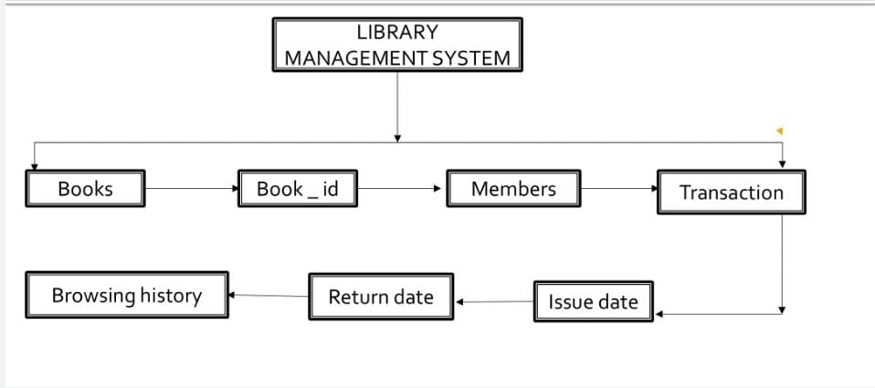

Figure 2.1

2.3 E-R DIAGRAM

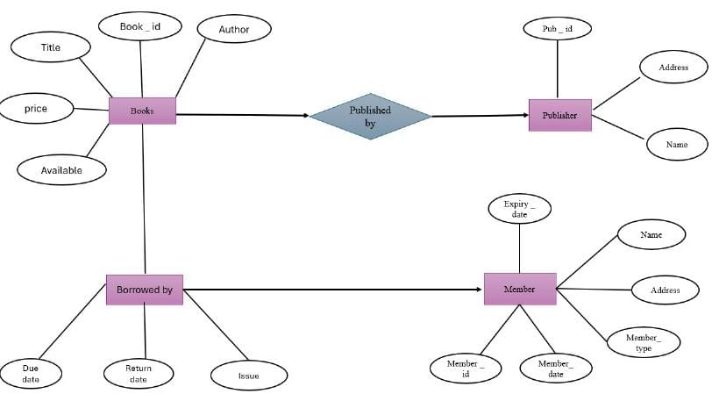

Figure 2.3 E-R DIAGRAM

CHAPTER 3
MODULE DESCRIPTION
3.1 Book Management Module
The Book Management Module is responsible for maintaining all details related to the library’s collection of books. It allows librarians to add new books, update existing records, and remove outdated or damaged books from the database. Each book record includes fields such as Book_ID, Title, Author, Publisher, Edition, Subject, and Availability_Status.

3.2. Member Management Module
This module handles the registration and management of library members. It collects and stores data such as Member_ID, Name, Contact Information, Membership Start Date, and Membership Status. The module also tracks individual borrowing history, current borrowed books, and any outstanding fines. It provides the librarian with a comprehensive view of each member's activity and allows for updating member information or deactivating accounts when needed.

3.3. Issuance and Return Module
The Issuance and Return Module automates the process of lending books to members and recording their return. When a book is issued, the system logs the Book_ID, Member_ID, Issue_Date, and sets a Due_Date. On return, it updates the Return_Date and automatically adjusts the book’s availability status in the database.

3.4. Fine Management Module
This module calculates and maintains fines for books returned after their due date. It uses predefined rules (e.g., daily fine amount) to determine how much a member owes based on the number of overdue days. The system automatically updates the fine records when a late return is processed in the Issuance and Return Module. Librarians can also view, waive, or collect fines using this module. It helps ensure that members are accountable and encourages timely returns.

3.5. Search and Catalog Module
The Search and Catalog Module enables users—both librarians and members—to search the library’s catalog based on various criteria such as title, author, subject, publisher, or ISBN. It retrieves relevant information from the database and displays results along with book availability and location within the library. This module enhances user experience by supporting filters and keyword-based searches, making it easier to find desired materials quickly and efficiently.

3.6. Login and User Access Control Module
This security-focused module manages user authentication and role-based access. Each user (Admin, Librarian, Member) logs in with unique credentials, and access is granted based on predefined permissions. For example, only admins can add staff users, while members can only view and search books. This module ensures data privacy, prevents unauthorized changes, and logs all user activities for system transparency.

3.7. Reports and Analytics Module
The Reports and Analytics Module is used to generate insights and summaries related to library operations. It can produce reports on issued and returned books, overdue items, fine collections, member activity, and book popularity. These reports help librarians and administrators monitor trends, make decisions on book acquisitions, and improve overall library services.

CHAPTER 4
RESULTS AND DISCUSSION

4.1 Login Page

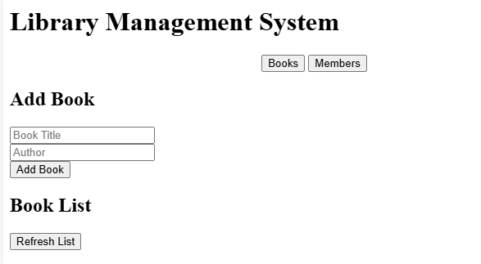

Figure 4.1
Description:
This is a Login Module interface typically used in web or mobile applications. It contains input fields for entering a Username and Password. The green Login button submits the user credentials for authentication. If the user does not have an account, a Sign up link is provided for registration. This module helps restrict access to authorized users only.

4.2 Enter book details

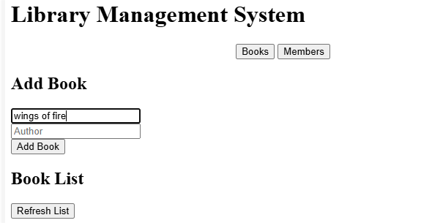

Figure 4.2

Description:
This is a simple Library Management System web interface built with HTML and CSS.It allows users to add books by entering the title, author name, and ISBN number.

4.3 Enter user details

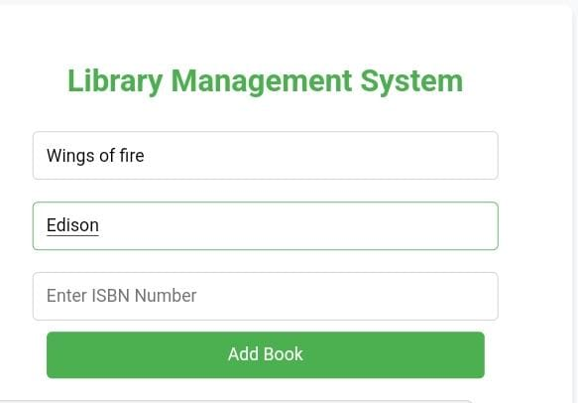

Figure 4.3

Description:
The user has typed “Edison” as the author name for the book “Wings of Fire.”The interface awaits the ISBN number to complete the book entry.It provides a simple, user-friendly form for adding books to the digital library

4.4 Enter ISBN number

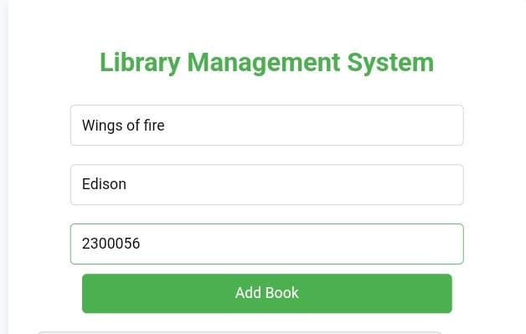

Figure 4.4

Description:
The user has entered the book title "Wings of Fire", author "Edison", and ISBN "2300056".The green "Add Book" button is ready to be clicked to submit the book details.Once submitted, the book will be listed under the "Library Books" section below.

4.5 Library database page

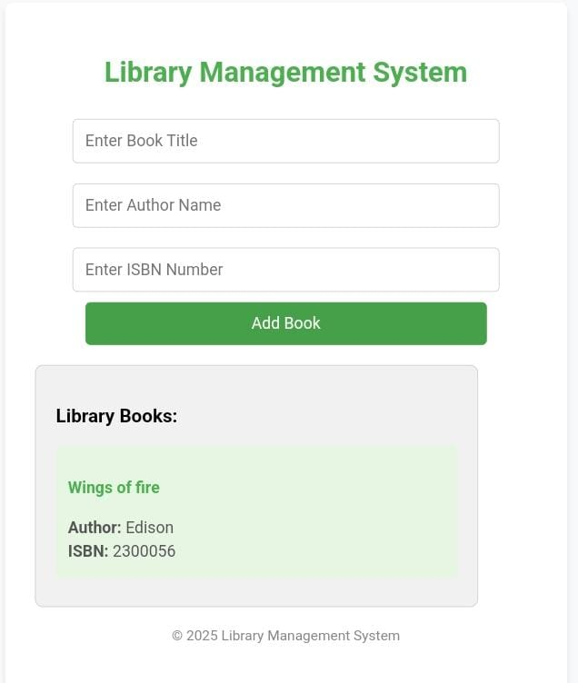

Figure 4.5

Description:
The interface allows users to enter book details—title, author, and ISBN—and add them to a visible list. The design uses styled input fields and buttons with soft colors and rounded edges. The application updates the book list dynamically without reloading the page.

CHAPTER 5
CONCLUSION
In conclusion, the Library Management System (LMS) is a vital tool for modernizing and automating the operations of a library. The transition from traditional manual methods to a DBMS-powered LMS not only enhances the overall functionality of libraries but also significantly improves the efficiency, accuracy, and security of managing library resources. By centralizing all information related to books, members, transactions, and reports into a digital database, the LMS eliminates the errors, delays, and difficulties inherent in paper-based systems. The use of a relational database ensures data consistency and integrity, allowing libraries to maintain a well-organized catalog that is easily accessible and searchable.The system's modular design, with distinct components such as book management, member registration, book issuance and return tracking, fine management, and reporting, allows for a comprehensive approach to library operations. Each module contributes to streamlining specific tasks. For example, the Book Management Module ensures that the inventory is up-to-date and easy to navigate, while the Member Management Module provides a clear record of users, their borrowing history, and overdue fines. The Issuance and Return Module automates the process of lending and returning books, which reduces manual work and enhances the accuracy of transactions. Similarly, the Fine Management Module ensures that overdue fines are calculated automatically, encouraging timely returns and generating revenue for the library.

REFERENCES:
[1] A. Al-Fuqaha, M. Guizani, M. Mohammadi, M. Aledhari, and M. Ayyash, “Internet of Things: A survey on enabling technologies, protocols, and applications,” IEEE Communications Surveys & Tutorials, vol. 17, no. 4, pp. 2347–2376, 2015, doi: 10.1109/COMST.2015.2444095.
[2] M. A. Jabbar, B. B. Meshram, and S. M. Kharat, “Digital library and its accessibility via cloud computing,” in Proc. IEEE Int. Conf. on Communication Systems and Network Technologies (CSNT), Rajkot, India, 2013, pp. 518–522, doi: 10.1109/CSNT.2013.111.
[3] R. Manoharan and R. Dhanasekaran, “Implementation of RFID technology in library management system,” International Journal of Computer Applications, vol. 69, no. 9, pp. 21–25, May 2013, doi: 10.5120/11852-7419.
[4] N. Patel and M. Patel, “Cloud-based library management system,” International Journal of Scientific and Research Publications, vol. 4, no. 10, pp. 1–4, Oct. 2014.
[5] S. Kumar, P. Tiwari, and M. Zymbler, “Internet of Things is a revolutionary approach for future technology enhancement: A review,” Journal of Big Data, vol. 6, no. 1, pp. 1–21, Dec. 2019, doi: 10.1186/s40537-019-0268-2.
[6] R. V. Dharaskar and V. M. Thakare, “Smart library management system using IoT,” in Proc. 2nd Int. Conf. on Inventive Systems and Control (ICISC), Coimbatore, India, 2018, pp. 935–939, doi: 10.1109/ICISC.2018.8399115.

11
APPENDIX
(Coding)
<!DOCTYPE html>
<html lang="en">
<head>
<meta charset="UTF-8">
<meta name="viewport" content="width=device-width, initial-scale=1.0">
<title>Library Management System</title>
<style>
body {
font-family: Arial, sans-serif;
background-color: #f8f9fa;
margin: 0;
padding: 0;
display: flex;
justify-content: center;
align-items: center;
height: 100vh;
flex-direction: column;
}
.container {
background-color: white;
padding: 30px;
border-radius: 8px;
box-shadow: 0 4px 6px rgba(0, 0, 0, 0.1);
width: 500px;
text-align: center;
}

h2 {
margin-bottom: 20px;
font-size: 28px;
color: #4CAF50;
}
.input-field {
width: 80%;
padding: 12px;
margin: 10px 0;
border: 1px solid #ccc;
border-radius: 5px;
font-size: 16px;
}
.input-field:focus {
border-color: #4CAF50;
outline: none;
}
.submit-btn {
width: 80%;
padding: 12px;
background-color: #4CAF50;
color: white;
border: none;
border-radius: 5px;
font-size: 16px;
cursor: pointer;
}
.submit-btn:hover {
background-color: #45a049;
}
.book-list {
width: 80%;
margin-top: 20px;
text-align: left;
background-color: #f1f1f1;
padding: 20px;
border-radius: 8px;
max-height: 300px;
overflow-y: auto;
border: 1px solid #ccc;
}
.book-item {
background-color: #e7f5e3;
padding: 12px;
margin: 8px 0;
border-radius: 5px;
}
.book-item h4 {
color: #4CAF50;
}
.book-item p {
margin: 5px 0;
color: #555;
}
.footer {
margin-top: 20px;
font-size: 14px;
color: #888;
}
</style>
</head>
<body>
<div class="container">
<h2>Library Management System</h2>
<!-- Form for adding books -->
<form id="bookForm">
<input type="text" class="input-field" id="bookTitle" placeholder="Enter Book Title" required>
<input type="text" class="input-field" id="bookAuthor" placeholder="Enter Author Name" required>
<input type="text" class="input-field" id="bookISBN" placeholder="Enter ISBN Number" required>
<button type="submit" class="submit-btn">Add Book</button>
</form>
<!-- Display added books -->
<div class="book-list" id="bookList">
<h3>Library Books:</h3>
<!-- Book items will be dynamically added here -->
</div>
<!-- Footer -->
<div class="footer">
<p>&copy; 2025 Library Management System</p>
</div>
</div>
<script>
// Array to hold the book details
let books = [];
// Function to update the book list in the output section
function updateBookList() {
const bookListDiv = document.getElementById('bookList');
bookListDiv.innerHTML = '<h3>Library Books:</h3>'; // Reset list title
if (books.length === 0) {
bookListDiv.innerHTML += '<p>No books available in the library.</p>';
} else {
books.forEach(book => {
const bookDiv = document.createElement('div');
bookDiv.classList.add('book-item');
bookDiv.innerHTML = `
<h4>${book.title}</h4>
<p><strong>Author:</strong> ${book.author}</p>
<p><strong>ISBN:</strong> ${book.isbn}</p>
`;
bookListDiv.appendChild(bookDiv);
});
}
}
// Handle form submission
document.getElementById('bookForm').addEventListener('submit', function(event) {
event.preventDefault(); // Prevent the default form submission
// Get the user input values
const title = document.getElementById('bookTitle').value;
const author = document.getElementById('bookAuthor').value;
const isbn = document.getElementById('bookISBN').value;
// Create a book object
const newBook = {
title: title,
author: author,
isbn: isbn
};
// Add the new book to the books array
books.push(newBook);
// Update the book list display
updateBookList();
// Clear form inputs
document.getElementById('bookTitle').value = '';
document.getElementById('bookAuthor').value = '';
document.getElementById('bookISBN').value = '';
});

// Initial display of book list (empty at the start)
updateBookList();
</script>
</body>
</html>

